Class :BankInfo

Methods :saving(),fixed(),deposit()

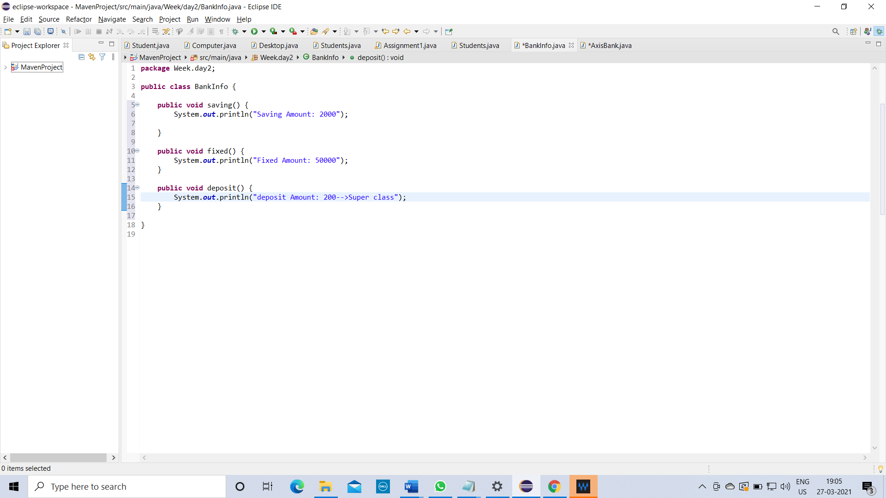

Class :AxisBank

Methods :deposit()

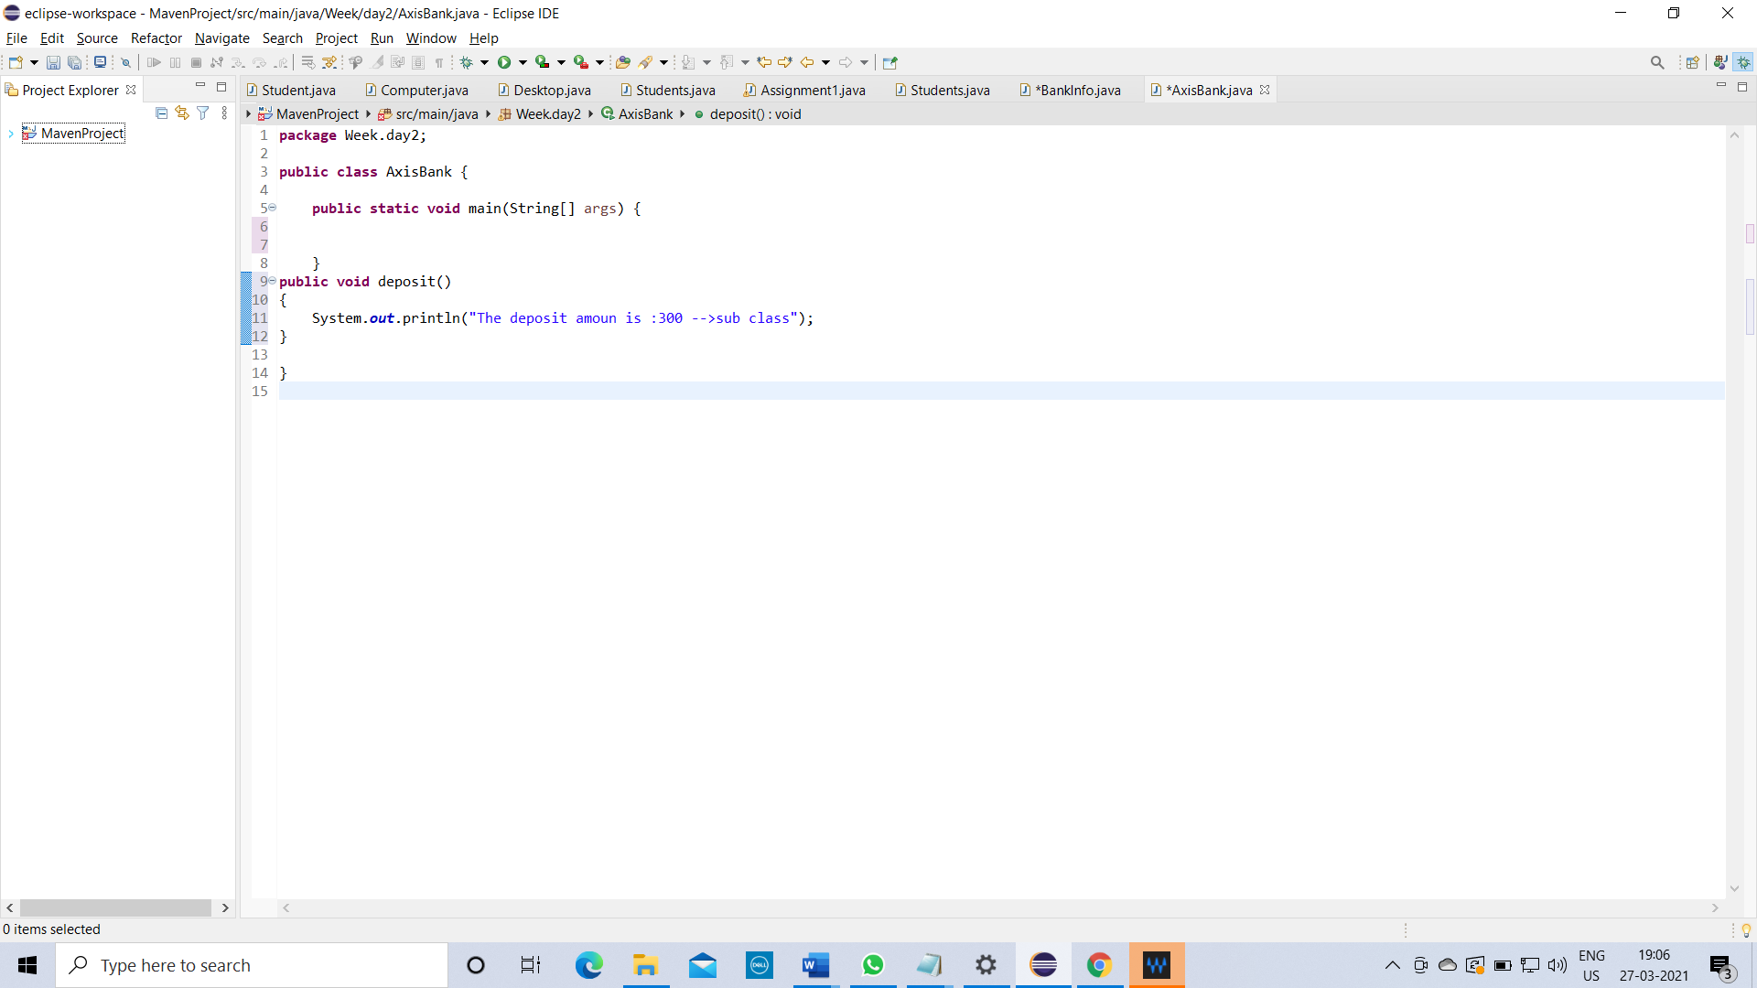

Description:

You have to override the method deposit in AxisBank.

